Ball Bouncing The Quadratic and Exponential Relationships
Members in Group: ___________________________________

Materials Needed: Fathom, Motion Detector, Ball, Brain

Pre-Questions:

When looking at a time distance graph, what would a ball bouncing look like? Draw your answer here. Don’t forget to label your axes.

What function best represents each bounce?

Do you see any correlation that would be exponential? What is it if any?

Lab:
1) Get into groups of two to three and keep up.
2) We will each run a ball bouncing experiment with different types of balls.
3) Running the experiment will require one student to hold the motion detector and one student to drop a ball. Time to Collect GOOD data.
4) In Fathom open a collection.
5) Plug in your motion detector and link your motion detector to your collection.
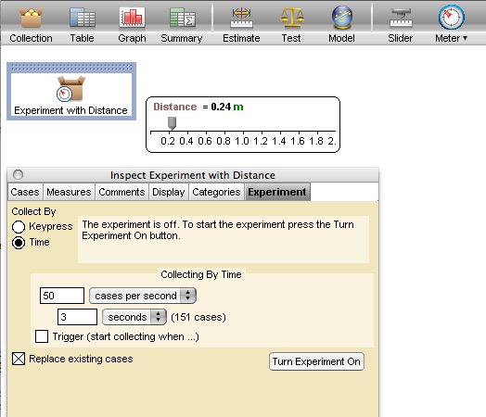
6) Set up the experiment for 3 seconds collecting
50 cases per second.

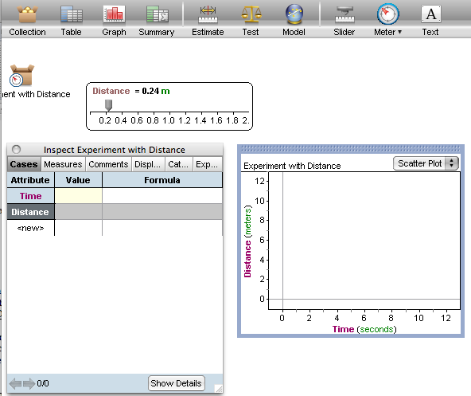
7) Pull down the graph and make a time vs. distance graph.

8) Run the experiment and collect data. Answer all question in complete sentences.

9) What do you notice from your graph? Why?

10) There are two major translations that need to happen to get the data “right side up” What are they?

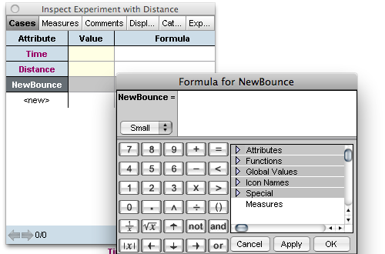
11) In your collection window under the cases tab create another attribute called NewBounce and perform the correct translations.
(Hint: you will need to preform appropriate
transformations to the “Distance” Attribute.)

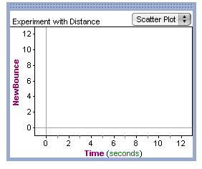
12) Create a new graph that compares Time vs NewBounce.

13) How many bounces did you get?
14) Create functions that will mimic each bounce (4 total) using vertex form of a quadratic. (Graph/Plot Function/VertexForm)

15) What did you notice about you’re a,h,k values? What values changed? What values stayed the same? Why?

16)Now lets find the maximums as an ordered pair of each parabolic bounce. Fill in the chart below.

Bounce | Maximum as an ordered pair
#1
#2
#3
#4

17) Can you see any relationship with the following maximums (y-values)? Hint: Find finite differences as a correlation and look for the most constant value.

1st Differences Constant?

2nd Differences Constant?

3rd Differences Constant?

Constant Common Ratios?

18) Once you have found the correlation you will now need to plot the new function that touches all the maximums. (Graph/Plot Function/Exp.Func)

19) Standard form of Exponential Functions is y=a(b)^{x}. What is your value for a and b in this equations.

20) What does the “a” value represent in this problem?

21) What does the “b” value represent in this problem?

22) Lets record everyone’s “b” values in a table.

Type of Ball | “b” Value

23) Is there any connection to the type of ball and “b” value? If so, what is it?

