**Investigating Screen Brightness**

**LCD Light and Holography**

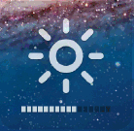**DESCRIPTION**: All monitors allow the user to adjust the brightness of the display screen to their desired level. In this activity, students will use the Vernier Light Sensor to measure the brightness adjustment at each increment for various computer monitors or cell phone screens. They will determine the type of model the data represents, which in turn will determine how the computer designer developed the brightness controls.

**MATERIALS**: computer screen(s) or cell phone(s) with brightness adjusting capabilities, fathom, logger lite, vcl, go!Link, Vernier Light Sensor

**BEFORE YOU BEGIN**:

Ask students to make a hypothesis about what model will represent the differences in the levels of brightness. Then have students explain their reasoning.

**SETTING UP THE EXPERIMENT**:

1. Connect the Go!Link cable to a USB drive on your computer.

2. Connect the Vernier Light Sensor to the Go!Link cable.

3. Open Logger Lite. The workspace should contain a table containing time and light level, plus a graph with the axes labeled for the experiment

4. Open the Experiment Menu and select Data Collection.

5. Under mode, select events with entry.

6. Under name, type brightness level and click done.

7. While adjusting the brightness on your screen, count the number of levels available (you will need this number later).

**CONDUCTING THE EXPERIMENT**:

Now you will investigate your conjecture about the mathematical relationship between different levels of brightness.

**COLLECT THE DATA**:

1. Set laptop or other device to highest brightness setting.
2. Press collect button. Note the “keep” option will now become available.
3. Hold the light probe directly against the screen and press keep.
4. You will be prompted to give a name to your brightness level, so assign a number (starting with the highest number you collected earlier).
5. Lower your brightness by one level.
6. Repeat steps 3 through 5 until data for each brightness level has been collected.

**ANALYZE AND INTERPRET THE DATA**:

1. Now that your data has been collected, we would like to examine the data using *Fathom*. To do this, the data must be exported in a compatible format. Go to the File Menu and select Export As. Choose CSV and save the file in a familiar location (i.e. Desktop).
2. Now the data is ready to import into *Fathom*. Open *Fathom* and under the File Menu select Import. You will see three options. Select Import from File and follow appropriate steps to open the file in the location you saved it to earlier.
3. Create a table from your data collection, and then create a graph by dragging the table attributes (keystroke and light intensity) to their appropriate locations on the graph.
4. Pull down sliders to use to determine the function that best models the data collected.
5. While graph is selected, under graph menu select plot function. Type a function that you believe best models your data using the variables from your sliders as your parameters.
6. Change the sliders until your model closely lines up with your data.

**FINAL THOUGHTS OR QUESTIONS**:

Students should compare the data they collected from various devices and compare models. Is there a trend for certain computers (ex. Mac vs. PC)?

How did the students’ models compare to their original hypotheses?

What element of the function must be restricted so that the computer does not go completely black (too dim) or go completely white (too bright)?

What does the y-intercept and the slope (if it is linear) for students’ models represent? How does in compare to the y-intercept and slope for other students and what does this mean?

If a student’s model is *not* linear, what would be the developer’s reasoning in using their model?

How would this investigation be conducted for a device that has a slider to change brightness level?

SAMPLE DATA:



PC (Lenovo laptop) data

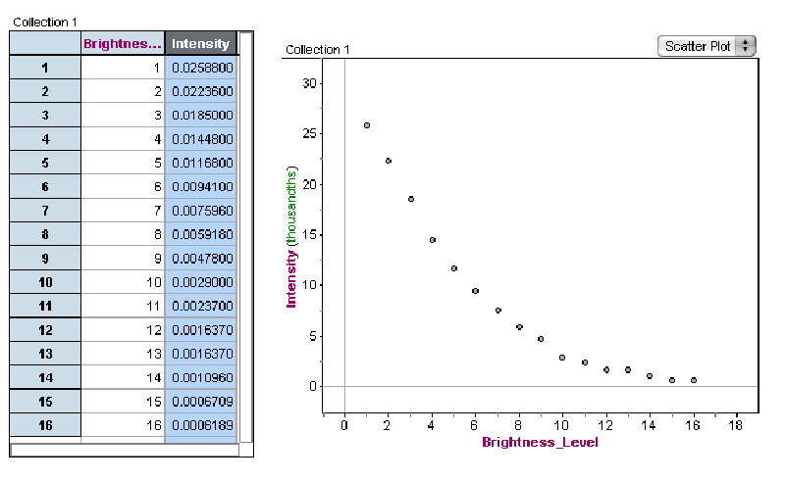

Mac laptop data