Examining Bouncing Balls with Fathom

Introduction:

Imagine what happens when you drop a ball onto a hard surface, such as a floor. The ball will descend, hit the surface, and then ascend back up. How does the height of the bouncing ball change over time? That is the question we will investigate in this experiment.

To investigate this question, we will collect data using the motion detector.

Data Collection:

- Plug the Motion Detector into the USB port of the computer that is running Fathom.
- Select Motion Detector from the Meter and drag it to the Fathom window. If the motion detector is on, you should notice that distance measures are appearing in the Meter.
- Drag a Collection from the shelf and place it in the Fathom window. Drag the plug from the Meter to the Collection to make an Experiment. Collect by Time, and choose 30 cases per second for 5 seconds.

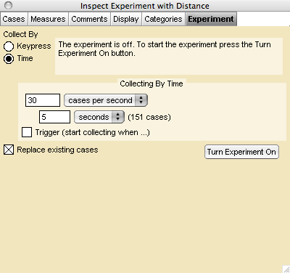

- Click on the Collection and drag a Case Table to the Window.
- Drag a Graph to the window and drag the attribute Distance to the dependent axis and the attribute Time to the independent axis.
- Make sure the Motion Detector setting is switched to the Ball. One person should hold the motion detector above the ball.

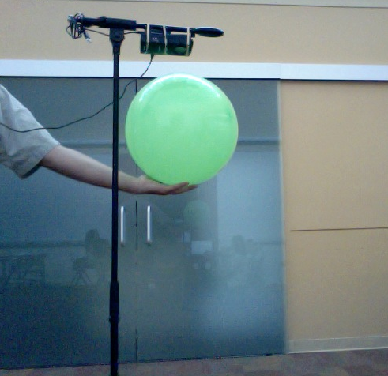

- Click Turn Experiment On and when the Motion Detector begins to click, drop the ball.
- Examine the data and graph. You may repeat steps 6 and 7 until you collect a “good” set of data.

Questions:

Q1. Describe the relationship between the graph of the bounce and the distance of the ball from the motion detector.

Q2. Use the graph to determine: the height of the motion detector from the floor, and the highest bounce of the ball.

Q3. Describe how you could transform the data so that the graph looks like the physical bounce of the ball. The greatest height of a single ball bounce is the maximum value of the graph.

Q4. Explain why the plot appears to look like the ball bounced across the floor.

Q5. Use sliders to create a mathematical model of a single bounce of the ball. Explain what each slider represents in terms of the context of the bouncing ball.

Explore More: Rebound Heights of Balls

Q6. Bring down a new Case Table. Input the time and greatest height for each bounce.

Q7. Determine the ratio between the heights for the each successive bounce.

Q8. Create a graph of distance versus time for the bounce heights.

Q9. Use sliders to create a function to model the rebound heights of the ball versus time. Explain the parameters in the function and how they are related to the context of the bouncing ball.

Adapted from http://www.vernier.com/experiments/rwcalc/11/thats_the_way_the_ball_bounces_-_height_and_time_for_a_bouncing_ball/

